**CMP4271: Online diary – Strategic and twitch skill**

**Introduction**

This week the group had to design a game that included strategic and twitch skill. The game was called Trivia: Explosion Edition and was a board type of game. It was a game that was played under a time constraint and involved answering questions in order to reach the centre of the board and defuse the bomb that was in the middle.

**Materials**

The game board was made using Paint.net

**Rules**

* Players must get into teams consisting of 1-4 players
* If your team answers a question correctly then they get + 5 seconds
* Each team has 8 minutes to start
* Timer starts counting down as soon as the game starts in a speed chess style (e.g stops at end of round
* Easy round consists of 5 questions (3 of 5 must be correct to advance)
* Normal consists of 3 questions (2 of 3 must be correct to advance)
* Hard  questions are asked until time has expired for each team or a team has 3 incorrect answers in a row
* The team to answer the most questions correctly in the bomb area defuses and wins the game
* No phones will be allowed during the game, avoiding cheating

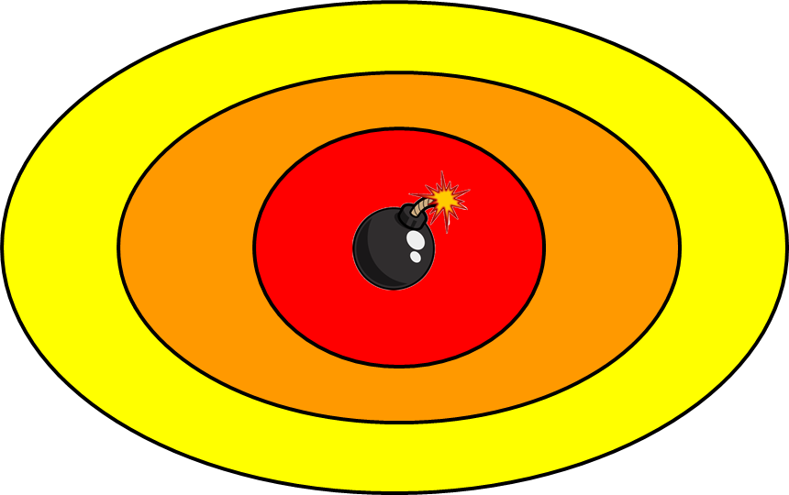**The board**

Figure 1, Mock-up game board.  [A] The yellow will be the starting stage with easy questions, [B] the orange stage is the middle ground with medium questions, [C] The red is the final stage where you are asked hard questions.

[B]

[A]

[C]

**Example Questions**

Figure 1

**Biology:**

**Easy**

* What is the human body's largest organ?

Answer: Skin

**Normal**

* How many bones are in each finger, except the thumb, of a human hand?

Answer: Three

**Hard**

* What are the members of a single type of living organism in an ecosystem called?

Answer: Population

Note; These are some of the example questions that the team decided to use.

**Play Testing**

From the internal play testing the team decided to change the final round from two hard questions, to how many question the player can answer correctly in a set time. This was done because the team later found that with only 2 hard questions the game ended in a tie most of the time.

The external play testing went very smoothly as,   
“The questions themselves were quite good and broad” - Muhammed Zulfqar  
This shows that the questions the team came up with were well rounded.

For any improvements of the game the team decided to add cards which included topics for the different questions, for example Maths, Biology, Geography etc, and use these so a player had to pick a topic and answer the questions. To prevent players from picking the same topic they know a lot about, the team decided that whenever a topic has been chosen a player, the same topic cannot be picked again from the said player. This was included and variety of questions were asked and made the game harder for the players.

**Teamwork**

The group consisted of four people and each was given a task to do after the idea of the game was created.

**Reflection**

After the team finished with the game, they commonly agreed on the improvements that they had to make in order for the game to be more fun and enjoyable for the players.